**Assignment 9 – Angular**

* Modify Assignment5 by using Angular (There should be carousel and other requirements which was specified as per assignment 5)
* Create login and sign up page using routing from first page
* Use localstorage/ session/cookies to store User object across all pages
* Use express to store user details in database
* Add validations wherever necessary
* Validate if username exists in both sign up and login page
* Create a static header and footer as shown in the lab for all the pages
* Once the user logins, create a new page as per your project (this should not same as home page)
* Use modal instead of alert (Don’t use alert pop ups anywhere in the project)

Example:

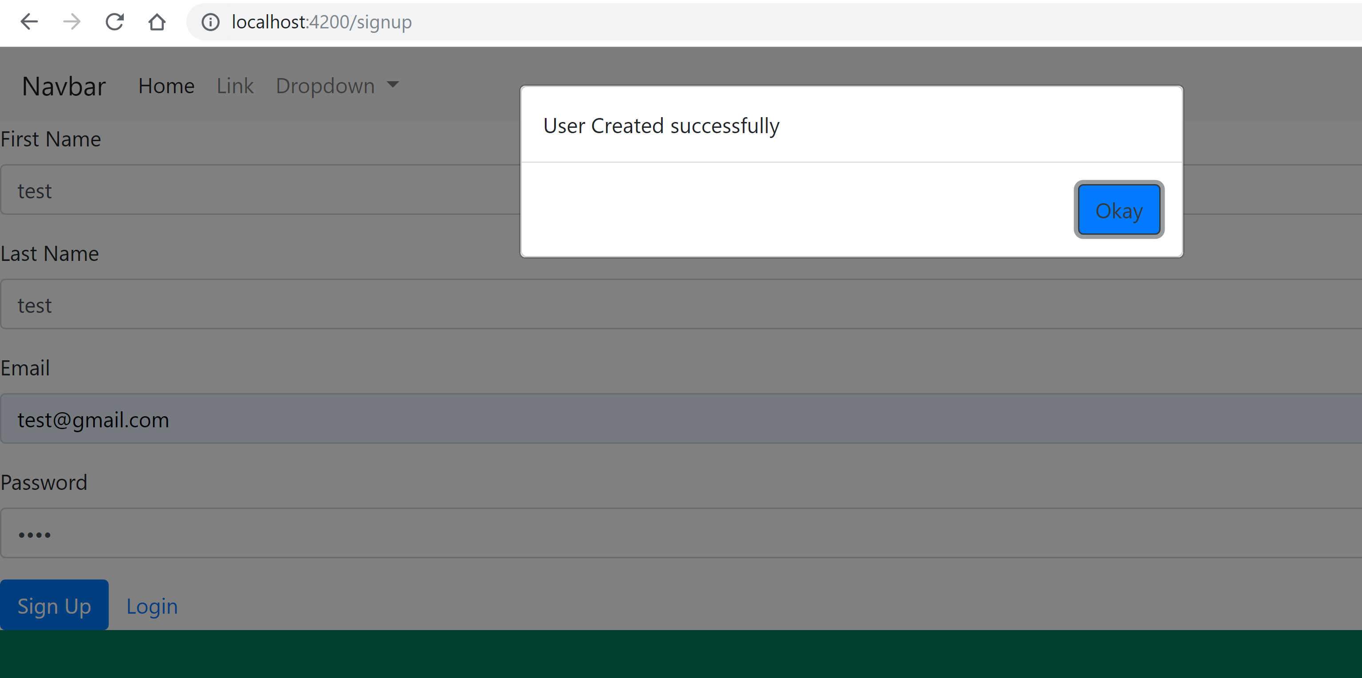

Note: Refer latest angular lab to know how to create modals in angular

* Create simple pages for all footer and header links so that it routes to different page

**Note: This is a group assignment**